**Langkah menghubungkan folder lokal dengan repository github**

1. Install git
2. Buat akun github
3. Buat repository di github (online)
4. Buat folder di local
5. Buka folder tersebut di **vs code** dan didalamnya buatkan file.py bebas

6. Buka gitbash

7. set username **github**, set email **github**

git config --global user.name "xxxx”

git config --global user.email “[xxxxx@gmail.com](mailto:xxxxx@gmail.com)”

git config –list 🡪 Untuk cek konfigurasi email dan username sudah terintegrasi di komputer lokal

8. arahkan directory git bash ke folder yang berisi file.py dengan command cd, ls, pwd

Misalnya folder DEMO dibuat pada Desktop. Maka untuk mengarahkan repository gunakan perintah berikut:

cd Desktop

cd DEMO

9. Untuk menghubungkan folder/repo lokal ke repo online di github gunakan perintah git init

git init 🡪 buat repo local



10. buka browser copy di repository github ke git

git remote add origin …..

git branch -M main

git push -u origin main ->>>>> BIASANYA ERROR

git add . ->>>> masukkan ke stagging

git commit -m “project pertamaku”

git push -u origin main



Sapto Wahyu Sudrajat@ThinkPad-X1Yoga MINGW64 ~

$ git config --global user.name "saptosudrajat"

Sapto Wahyu Sudrajat@ThinkPad-X1Yoga MINGW64 ~

$ git config --global user.email "saptowahyusudrajat@gmail.com"

Sapto Wahyu Sudrajat@ThinkPad-X1Yoga MINGW64 ~

$ git config --list

diff.astextplain.textconv=astextplain

filter.lfs.clean=git-lfs clean -- %f

filter.lfs.smudge=git-lfs smudge -- %f

filter.lfs.process=git-lfs filter-process

filter.lfs.required=true

http.sslbackend=openssl

http.sslcainfo=C:/Program Files/Git/mingw64/etc/ssl/certs/ca-bundle.crt

core.autocrlf=true

core.fscache=true

core.symlinks=false

pull.rebase=false

credential.helper=manager

credential.https://dev.azure.com.usehttppath=true

init.defaultbranch=master

core.editor="C:\Users\Sapto Wahyu Sudrajat\AppData\Local\Programs\Microsoft VS C

ode\bin\code" --wait

user.name=saptosudrajat

user.email=saptowahyusudrajat@gmail.com

Sapto Wahyu Sudrajat@ThinkPad-X1Yoga MINGW64 ~

$ cd C:\Users\Sapto Wahyu Sudrajat\OneDrive - Institut Teknologi Sepuluh Nopember\Documents\!PARTISI\NGAJAR SKILVUL\WEEK4 GIT dan GITHUB

bash: cd: too many arguments

Sapto Wahyu Sudrajat@ThinkPad-X1Yoga MINGW64 ~

$ cd Documents

Sapto Wahyu Sudrajat@ThinkPad-X1Yoga MINGW64 ~/Documents

$ ls

'!PARTISI'/ Lightshot/ 'My Music'@ 'My Videos'@ libraries/

ATAS/ MATLAB/ 'My Pictures'@ 'Visual Studio 2019'/ slprj/

Sapto Wahyu Sudrajat@ThinkPad-X1Yoga MINGW64 ~/Documents

$ cd !PARTISI

bash: !PARTISI: event not found

Sapto Wahyu Sudrajat@ThinkPad-X1Yoga MINGW64 ~/Documents

$ cd !PARTISI/

bash: !PARTISI/: event not found

Sapto Wahyu Sudrajat@ThinkPad-X1Yoga MINGW64 ~/Documents

$ cd My Music

bash: cd: too many arguments

Sapto Wahyu Sudrajat@ThinkPad-X1Yoga MINGW64 ~/Documents

$ ls

'!PARTISI'/ Lightshot/ 'My Music'@ 'My Videos'@ libraries/

ATAS/ MATLAB/ 'My Pictures'@ 'Visual Studio 2019'/ slprj/

Sapto Wahyu Sudrajat@ThinkPad-X1Yoga MINGW64 ~/Documents

$ ^C

Sapto Wahyu Sudrajat@ThinkPad-X1Yoga MINGW64 ~/Documents

$ cd '!PARTISI'/

Sapto Wahyu Sudrajat@ThinkPad-X1Yoga MINGW64 ~/Documents/!PARTISI

$ ls

'!PERLENGKAPAN PASCASARJANA'/ 'BACKUP LAPTOP EVITS'/ 'PINDAH SOFTWARE'/

Sapto Wahyu Sudrajat@ThinkPad-X1Yoga MINGW64 ~/Documents/!PARTISI

$ cd 'NGAJAR SKILVUL'/

bash: cd: NGAJAR SKILVUL/: No such file or directory

Sapto Wahyu Sudrajat@ThinkPad-X1Yoga MINGW64 ~/Documents/!PARTISI

$ ls

'!PERLENGKAPAN PASCASARJANA'/ 'BACKUP LAPTOP EVITS'/ 'PINDAH SOFTWARE'/

Sapto Wahyu Sudrajat@ThinkPad-X1Yoga MINGW64 ~/Documents/!PARTISI

$ cd videos

bash: cd: videos: No such file or directory

Sapto Wahyu Sudrajat@ThinkPad-X1Yoga MINGW64 ~/Documents/!PARTISI

$ cd~

bash: cd~: command not found

Sapto Wahyu Sudrajat@ThinkPad-X1Yoga MINGW64 ~/Documents/!PARTISI

$ cd ..

Sapto Wahyu Sudrajat@ThinkPad-X1Yoga MINGW64 ~/Documents

$ cd ..

Sapto Wahyu Sudrajat@ThinkPad-X1Yoga MINGW64 ~

$ cd ~

Sapto Wahyu Sudrajat@ThinkPad-X1Yoga MINGW64 ~

$ cd Videos

Sapto Wahyu Sudrajat@ThinkPad-X1Yoga MINGW64 ~/Videos

$ ls

'03 SERIAL COMMUNICATION'/ Graphics/ IMU_simulinik.slxc SKETCH_ARDUINO/

AnyDesk/ 'HD Movie Maker'/ IMU_simulinik_ert_rtw/ desktop.ini

Arduino/ IMU_SImulink_serial/ KUNUNGAN_UNAS_2_ESP_SERVER/ flypath3d/

'Backup of F16'/ IMU_simulinik.eep 'NGAJAR SKILVUL'/ human_obt/

CM530-master/ IMU_simulinik.elf 'Percobaan LQR_6022202020.docx' libraries/

Captures/ IMU_simulinik.hex RLS_IMU_DEMO.slx slprj/

F16model-master/ IMU_simulinik.slx RLS_IMU_DEMO.slx.autosave stm32-master/

Sapto Wahyu Sudrajat@ThinkPad-X1Yoga MINGW64 ~/Videos

$ cd 'NGAJAR SKILVUL'/

Sapto Wahyu Sudrajat@ThinkPad-X1Yoga MINGW64 ~/Videos/NGAJAR SKILVUL

$ ls

'WEEK4 GIT dan GITHUB'/

Sapto Wahyu Sudrajat@ThinkPad-X1Yoga MINGW64 ~/Videos/NGAJAR SKILVUL

$ cd WEEK4 GIT dan GITHUB

bash: cd: too many arguments

Sapto Wahyu Sudrajat@ThinkPad-X1Yoga MINGW64 ~/Videos/NGAJAR SKILVUL

$ cd 'WEEK4 GIT dan GITHUB'

Sapto Wahyu Sudrajat@ThinkPad-X1Yoga MINGW64 ~/Videos/NGAJAR SKILVUL/WEEK4 GIT dan GITHUB

$ pwd

/c/Users/Sapto Wahyu Sudrajat/Videos/NGAJAR SKILVUL/WEEK4 GIT dan GITHUB

Sapto Wahyu Sudrajat@ThinkPad-X1Yoga MINGW64 ~/Videos/NGAJAR SKILVUL/WEEK4 GIT dan GITHUB

$ git init

Initialized empty Git repository in C:/Users/Sapto Wahyu Sudrajat/Videos/NGAJAR SKILVUL/WEEK4 GIT dan GITHUB/.git

/

Sapto Wahyu Sudrajat@ThinkPad-X1Yoga MINGW64 ~/Videos/NGAJAR SKILVUL/WEEK4 GIT dan GITHUB (master)

$ git remote add origin https://github.com/saptosudrajat/matematika_sd.git

Sapto Wahyu Sudrajat@ThinkPad-X1Yoga MINGW64 ~/Videos/NGAJAR SKILVUL/WEEK4 GIT dan GITHUB (master)

$ git branch -M main

Sapto Wahyu Sudrajat@ThinkPad-X1Yoga MINGW64 ~/Videos/NGAJAR SKILVUL/WEEK4 GIT dan GITHUB (main)

$ git push -u origin main

error: src refspec main does not match any

error: failed to push some refs to 'https://github.com/saptosudrajat/matematika_sd.git'

Sapto Wahyu Sudrajat@ThinkPad-X1Yoga MINGW64 ~/Videos/NGAJAR SKILVUL/WEEK4 GIT dan GITHUB (main)

$ git add .

Sapto Wahyu Sudrajat@ThinkPad-X1Yoga MINGW64 ~/Videos/NGAJAR SKILVUL/WEEK4 GIT dan GITHUB (main)

$ git commit -m "first project alat hitung luas bangun 2 dimensi"

[main (root-commit) cd89437] first project alat hitung luas bangun 2 dimensi

1 file changed, 7 insertions(+)

create mode 100644 tesaplikasi.py

Sapto Wahyu Sudrajat@ThinkPad-X1Yoga MINGW64 ~/Videos/NGAJAR SKILVUL/WEEK4 GIT dan GITHUB (main)

$ git push -u origin main

info: please complete authentication in your browser...

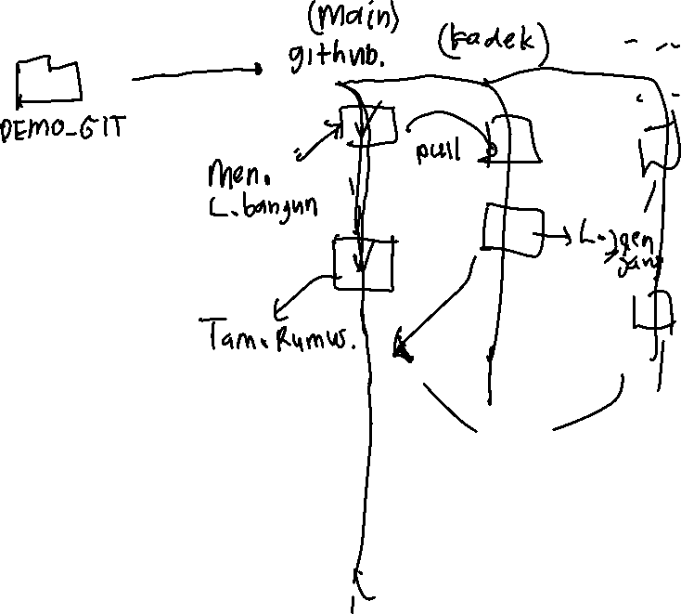

i

